Year 8 German Semester 1 CAT 2

TOPIC: Essen

CAT TASK/NUMBER: CAT 2: Food Specialities from Germany

LEARNING GOALS:
- Students will become familiar with a number of different German specialities, learning the names of the dishes, the areas they come from, the ingredients in them and how some taste.
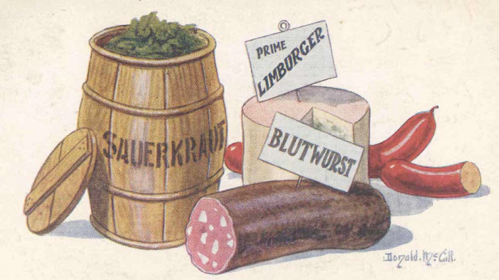
- Students will cook a German speciality
- Students will recognise the German words for some ingredients.

DESCRIPTION: Students must complete all 3 of the following parts:

Part 1: Research regional specialities

Locate a map of Germany and choose a region to investigate its regional specialities
(choose a region from http://www.germanfoods.org/consumer/facts/foodregions.cfm)
    - Find 3 Food/Drink Specialties that are completely different [e.g. sweet, savoury, vegetarian, drink] and find photos for your project.
    - Find a recipe website and give some background information about the specialties. Is there a story/history connected to it? Is it served at a particular time of the year?
    - Why do you think you or your own family would/would not enjoy these specialties? Would you try them if you visited your region? Why / why not?

Part 2: Planning and Cooking
Choose 1 of the above specialties and cook/prepare it at home for at least 3 other people to review. This involves you creating and EATING! Think about which dishes are best suited to your cooking ability and your reviewers.
For one speciality, research and write out the ingredients in GERMAN and ENGLISH.
- Are there any special techniques or skills involved in making your specialty? (in English)
ii) Are all the ingredients available at Coles/Woolworths/Aldi or must you go to specialty shops?
iii) Create a place card to sit with your food on a table at a tasting session. This card must include what the food is, where it comes from and what it contains IN GERMAN.
    - Cook / Prepare your chosen speciality at home and get at least 3 people to taste it.
**Since this is being done at home it would be great if you could take some photos of the process of cooking and tasting and submit them with your work**
Part 3: Food Review
Ask the 3 people who tasted your food to give you feedback. Take photos of them tasting the food.
Annotate the photos with captions in German saying what the reviewers thought of your food. You also need to give your own opinion in German of the food you prepared.

Part 4: Bibliography
Students must use at least 4 sources to
locate information. The bibliography should be written in a correct format.

.

CONDITIONS:
- Students will be given approximately 2 weeks to prepare for this CAT.
- Students must work on this task INDIVIDUALLY.
- Students may choose the format they wish to present the written components in. Suggestions include Electronic Formats (Document, Presentation, Website), Videos, and Scrapbooks. Students should keep in mind the time parameters of this task when choosing their presentation format.

SUCCESS CRITERIA:
Students will receive competency if they demonstrate capacity in the following:
 | Grades Given
Criteria | VH | H | M | L | NS
Part 1: Research into Regional Specialties
- Student has included a map of Germany, highlighting their chosen region
- Student has provided a depth and breadth of information (Background, History) on 3 specialities and not copy pasted
- Student has given an opinion about the suitability of this dish for his/her family and justified this opinion.

Part 2: Food Preparation
- Student has provided a list of ingredients in GERMAN and ENGLISH
- Student has provided a thorough analysis of the foods and preparation process.
- Student has cooked the food successfully.
- Student has provided a small place card stating what the food is, where it comes from and what it contains IN GERMAN.

Part 3: Food Review
- Student has submitted 4 reviews IN GERMAN
- Student’s use of German is correct and appropriate for the task.

Part 4: Bibliography

Student has attached a Bibliography

Student was able to locate relevant resources
- Student used at least 4 sources of information.

Other

Student has shown ability to choose and use an appropriate format for task

Student included a range of visuals for the task

Student’s work was easy to understand and information was set out in a logical manner.
Total Marks given | /75

ACE POINT WEIGHTING: 2 points * Tasks submitted late will make student ineligible for ACE Point for Timely Submission

TEACHER FEEDBACK: ________________________________________________________________
________________________________________________________________________________________________________________________________________________________________________________________________________________________________________________________________________________________________________________________________________________________

