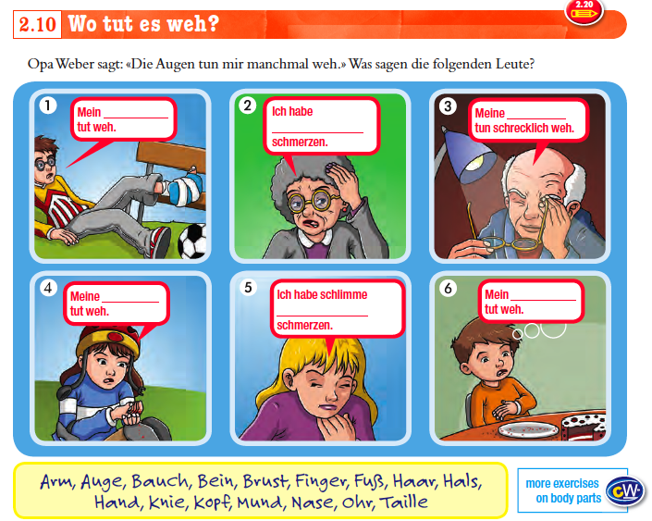
- Fill in the above spaces.

- Read picture 3. It states that Meine ….. tun weh! Why do you think it is tun weh and not tut weh? (HINT: Think singular/plural)

- Based on the above information write 2 sentences in your book which states that something hurts in the plural. i.e My Arms / my fingers hurt!

- Use a dictionary to find out the following phrases and write in your books
  - husten:
  - Ich bin krank! :
  - Ich bin verletzt:
  - Ich habe die Grippe:
  - Ich bin erkältet:
  - Ich habe ein Fieber:

- Revision: Learn these off by heart and write them into your books
  - Was ist los? = What is wrong?
  - Was tut weh? = What hurts?
  - Wo tut es weh? = Where does it hurt?
  - Seit wann?
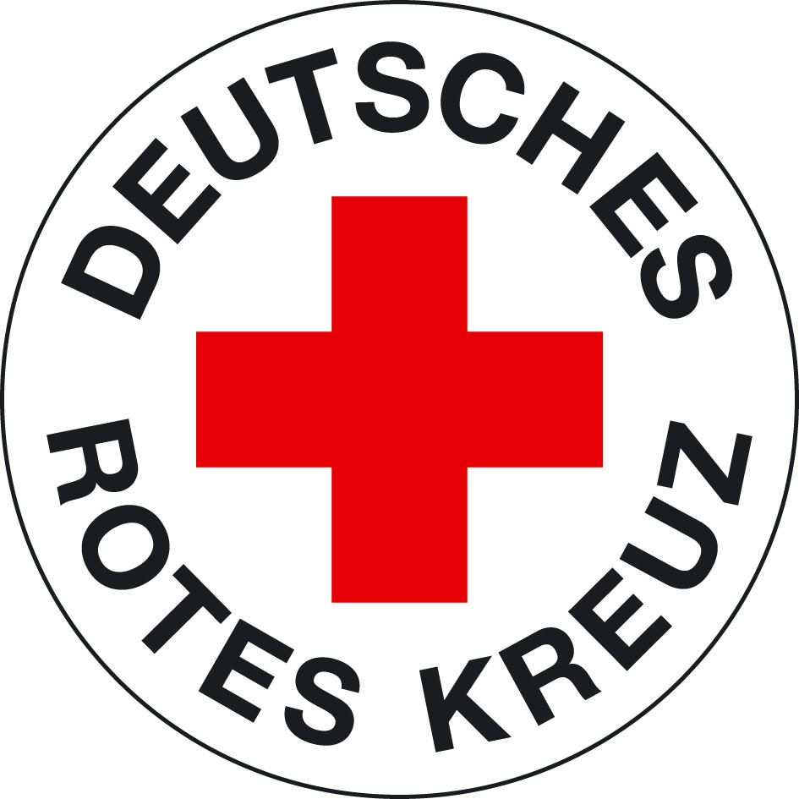
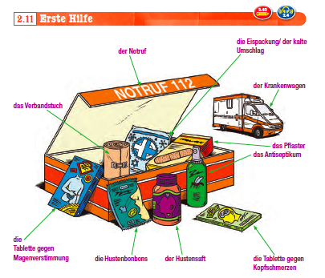
What do you think ‘erste Hilfe’ means?

- What is the emergency (=notruf) in Germany?

- Using a dictionary translate all the above words into English.
Also translate:
  - brauchen =
  - nehmen =

- ROLEPLAY 1:
Pretend you are a Mrs Morris, our school nurse (nurse = Krankenschwester). Write out a dialogue in German that might occur if you are feeling sick because you have a cold or if your were injured. Some of a sample has been completed below:

Good morning Mrs Morris Good Morning …. What is wrong?
I have a cold! Ok. Where does it hurt?
My throat hurts….. Take these tablets.

