Goethe film festival
Thema: JugendCoolTour

Das Drehbuch: the Screenplay

Now that you have completed your brief synopsis (an outline of your film), you must complete a SCREENPLAY.

A SCREENPLAY will give a scene by scene analysis of what your film will be about. Each scene should have about 3-4 sentences, detailing the contents of that moment in the film. You do not at this stage need to write a script, but it may have a key phrase that you wish to include or remember.

Next Lesson you will use your screenplay to begin writing your script.

The Screenplay must be finished by the start of the next lesson.

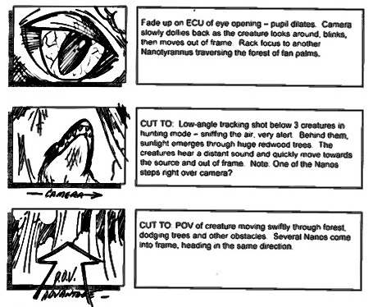

Example Storyboarding/Screenplay:
Note how there is no script, but gives an overview of each scene. It introduces what will be in each scene (i.e actors/props) and camera angles/editing required.

