**SUBJECT: Yr 8 GERMAN**

|  |  |
| --- | --- |
| TOPIC: | “Die Ratte” Topic 10 (Term 4) |
| CAT TASK: | CAT 2: SPEAKING TASK (ANIMAL CONVERSATION) |
| DESCRIPTION: | Students will write perform an interview about animals in German.  Students will need to discuss animals giving descriptions [colour, age, character, body parts].They will need to describe what animals eat, where they live and the species [mammal, bird, etc] |
| CONDITIONS: | Students will be given time in class and for HW to prepare for their Role Play. They will then perform the conversation in pairs for the teacher during class time, without notes. |
| SUCCESS CRITERIA: | |  |  |  |  |  | | --- | --- | --- | --- | --- | | Criteria | Grades Given | | | | | * Student can accurately name animals * Can use **mein/e sein/e ihr/e** * Student can use adjectives after the noun  Student can accurately use verbs fressen, wohnen/auskommenStudent can make comparison using gern/lieber/am liebsten | H [5] | M [3] | L [1] | NS | | Total Marks given per task: | /25 | | | | |
| ACE POINTWEIGHTING: | Task: 1 point each for writing / speaking tasks in CAT 2 |
| |  |  | | --- | --- | | Questions 1. Welches Tier ist das? Pic A 2. Wie ist er / sie / es? 3. Hast du gern PLU ? oder magst du lieber PLU? 4. Welches Tier magst du am liebsten? 5. Wie heisst dieser/e/es ......... ? Pic B 6. Was frisst er sie es? 7. Welche Farbe ist sein/e ihr/e Fell, Feder Ohren Augen... 8. Woher kommt er sie es? Wo wohnt er sie es? Pic C 9. Ist er sie es ... ? [say an obviously incorrect adj] 10 Was für ein Tier ist ...? | Answer – Student must 1. Name animal pic A  2. Give age , colour and character 3. Say a preference between animal pic A or B 4. Say their favourite animal of pic A B or C 5. Give the name of pic B [der ... heisst Bruno] 6. Say what it eats 7. Give body part info 8. Say where Pic C animal comes from eg ocean desert 9. say an obviously correct adj to contradict 10 state if pic C is a mammal reptile | | |

[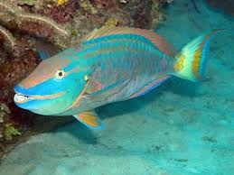](http://www.google.com.au/imgres?q=parrot&start=610&um=1&hl=en&safe=active&sa=N&biw=1366&bih=622&tbm=isch&tbnid=sV2gqHrY9PGe3M:&imgrefurl=http://www.itsallaboutfish.co.uk/parrot_fish.htm&docid=4DjUS3yTz1SGtM&imgurl=http://www.itsallaboutfish.co.uk/Pictures/Parrot_Fish.JPG&w=500&h=375&ei=h1CCUMbEKoe8iAeVsoDQBw&zoom=1&iact=hc&vpx=542&vpy=110&dur=3983&hovh=194&hovw=259&tx=85&ty=85&sig=103859684178009777593&page=24&tbnh=130&tbnw=173&ndsp=26&ved=1t:429,r:26,s:600,i:82)[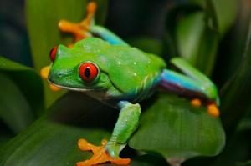](http://images.sciencedaily.com/2007/05/070501075044-large.jpg)

**Bert 10 Kermit 2**

[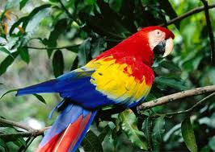](http://www.google.com.au/imgres?q=parrot&start=212&um=1&hl=en&safe=active&sa=N&biw=1366&bih=622&tbm=isch&tbnid=SzLMQaTfZU5H4M:&imgrefurl=http://www.pubwages.com/44/how-to-train-a-parrot&docid=218nAuK5SYNWZM&imgurl=http://www.pubwages.com/wp-content/uploads/2011/06/Beautiful-parrot1.jpg&w=400&h=285&ei=L1CCUJuvMeGjigfh2IGQCA&zoom=1&iact=hc&vpx=344&vpy=119&dur=187&hovh=189&hovw=266&tx=120&ty=85&sig=103859684178009777593&page=9&tbnh=139&tbnw=191&ndsp=28&ved=1t:429,r:21,s:200,i:67)[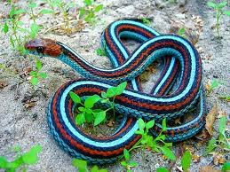](http://www.google.com.au/imgres?q=pretty+snakes&start=141&um=1&hl=en&safe=active&biw=1366&bih=622&tbm=isch&tbnid=HyWKLdjoyTyF3M:&imgrefurl=http://www.aussiepythons.com/forum/general-reptile-discussion-42/snake-id-173036/&docid=vqeDHM8H-98IYM&imgurl=http://i39.photobucket.com/albums/e170/mysnakesau/SNAKE.jpg&w=500&h=375&ei=U1KCUJ6sCMihigeijIHIAg&zoom=1&iact=hc&vpx=749&vpy=2&dur=3953&hovh=194&hovw=259&tx=176&ty=74&sig=103859684178009777593&page=7&tbnh=128&tbnw=166&ndsp=25&ved=1t:429,r:63,s:100,i:193)

**Ralf 14 Paris 4**

[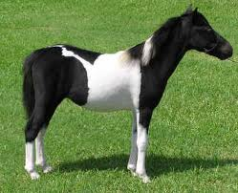](http://www.google.com.au/imgres?q=horses&start=115&um=1&hl=en&safe=active&biw=1366&bih=622&tbm=isch&tbnid=PknRdYLu8gae1M:&imgrefurl=http://www.squidoo.com/miniature-horse&docid=hTlwzEYr8Q1D0M&imgurl=http://i3.squidoocdn.com/resize/squidoo_images/-1/lens19364411_b15d1403f6d111ba9a6797e033feeae5.jpg&w=374&h=304&ei=3VOCUKHxDaeiiAef44GQBA&zoom=1&iact=hc&vpx=1074&vpy=2&dur=1267&hovh=202&hovw=249&tx=205&ty=73&sig=103859684178009777593&page=6&tbnh=139&tbnw=187&ndsp=26&ved=1t:429,r:33,s:100,i:103)[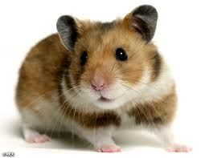](http://www.google.com.au/imgres?q=hamster&um=1&hl=en&safe=active&biw=1366&bih=622&tbm=isch&tbnid=ts_uIjRCy-ymQM:&imgrefurl=http://www.foxy-shop.com/products/hamster/&docid=Q9-Sa9AyCtUKUM&imgurl=http://www.foxy-shop.com/wp-content/uploads/2011/02/HamsterREX_468x3621.jpg&w=468&h=362&ei=c1SCUNvCKeqZiAeDkYCADQ&zoom=1&iact=hc&vpx=118&vpy=130&dur=1935&hovh=197&hovw=255&tx=143&ty=89&sig=103859684178009777593&page=1&tbnh=135&tbnw=175&start=0&ndsp=20&ved=1t:429,r:0,s:0,i:65)

**Emma 12 Lulu 3**

